Al-Aqsa University  Faculty of Computers and IT  Dept. of Info & Computer science |  | جامعة الأقصى  كلية الحاسبات وتكنولوجيا المعلومات  قسم علم الحاسوب والمعلومات

Advanced Algorithm

Answers Of Assignment 3

Gaussian Elimination

Presented to: Eng. Firas Foad AL-Ejla

Student name: Deema Mohammed AL-Maqadma
Student number:2320230766

Semester: Second Semester 2024/2025
Q1/ Solve using Gaussian Elimination:

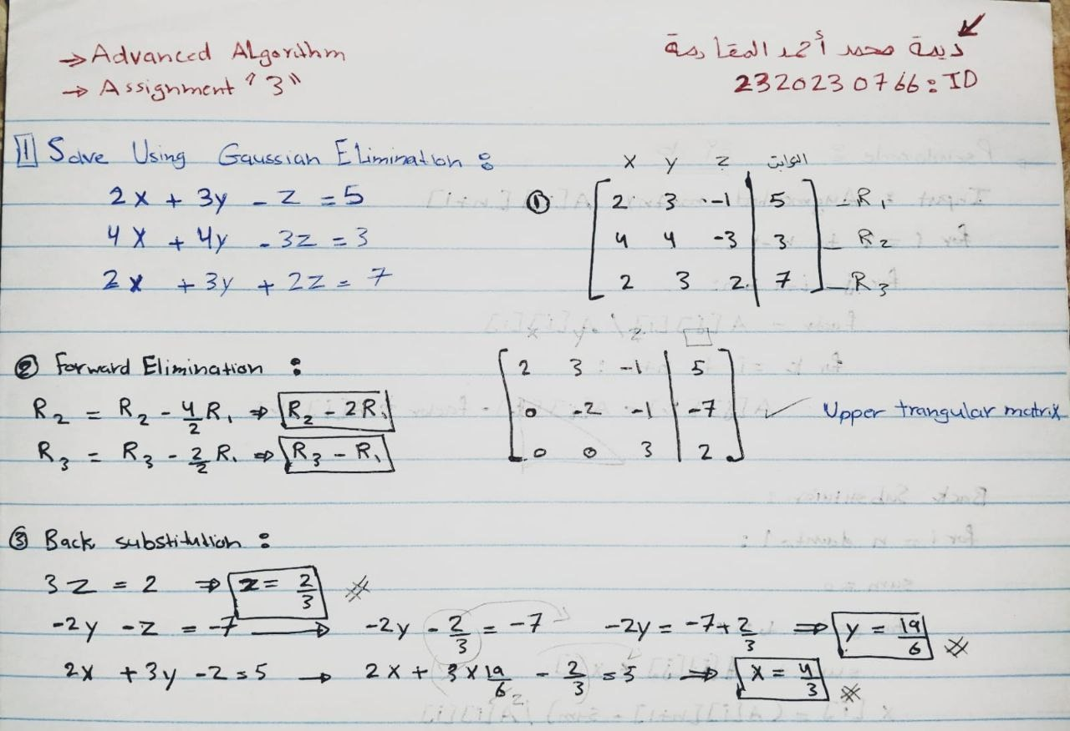

Q2/ Pseudo code of Gaussian Elimination:

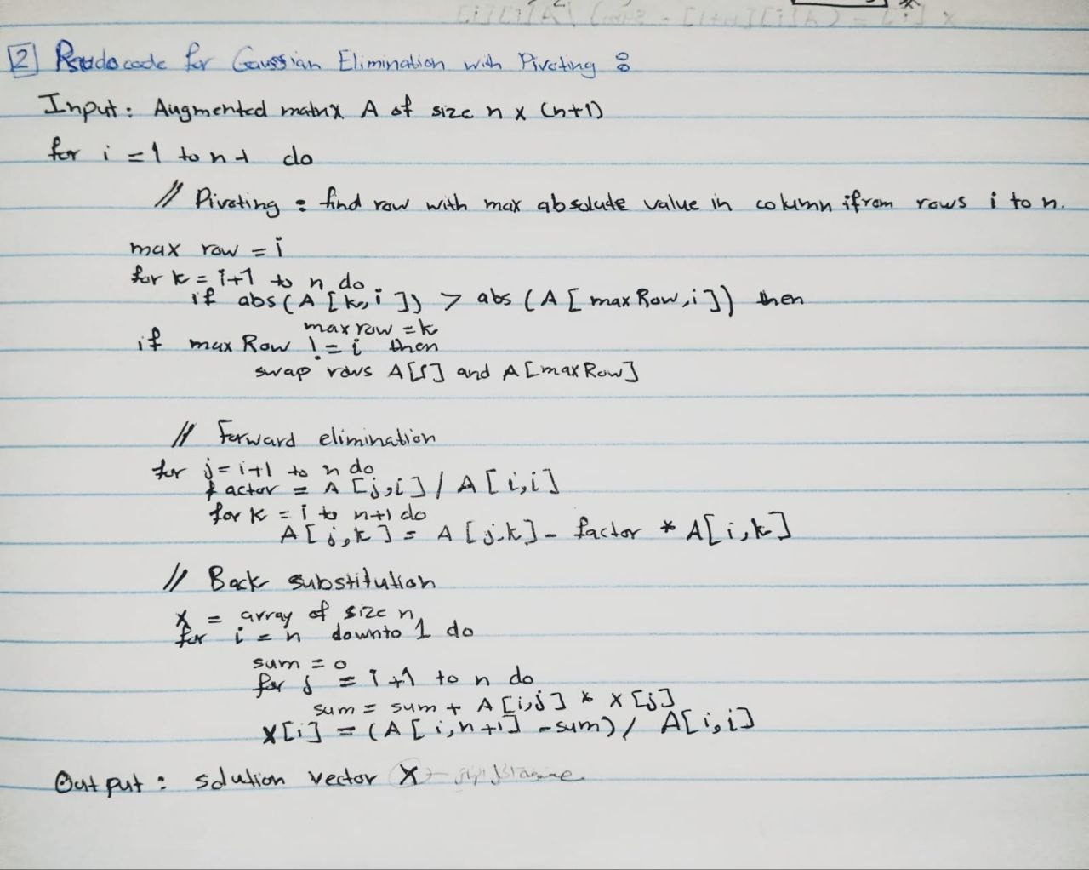
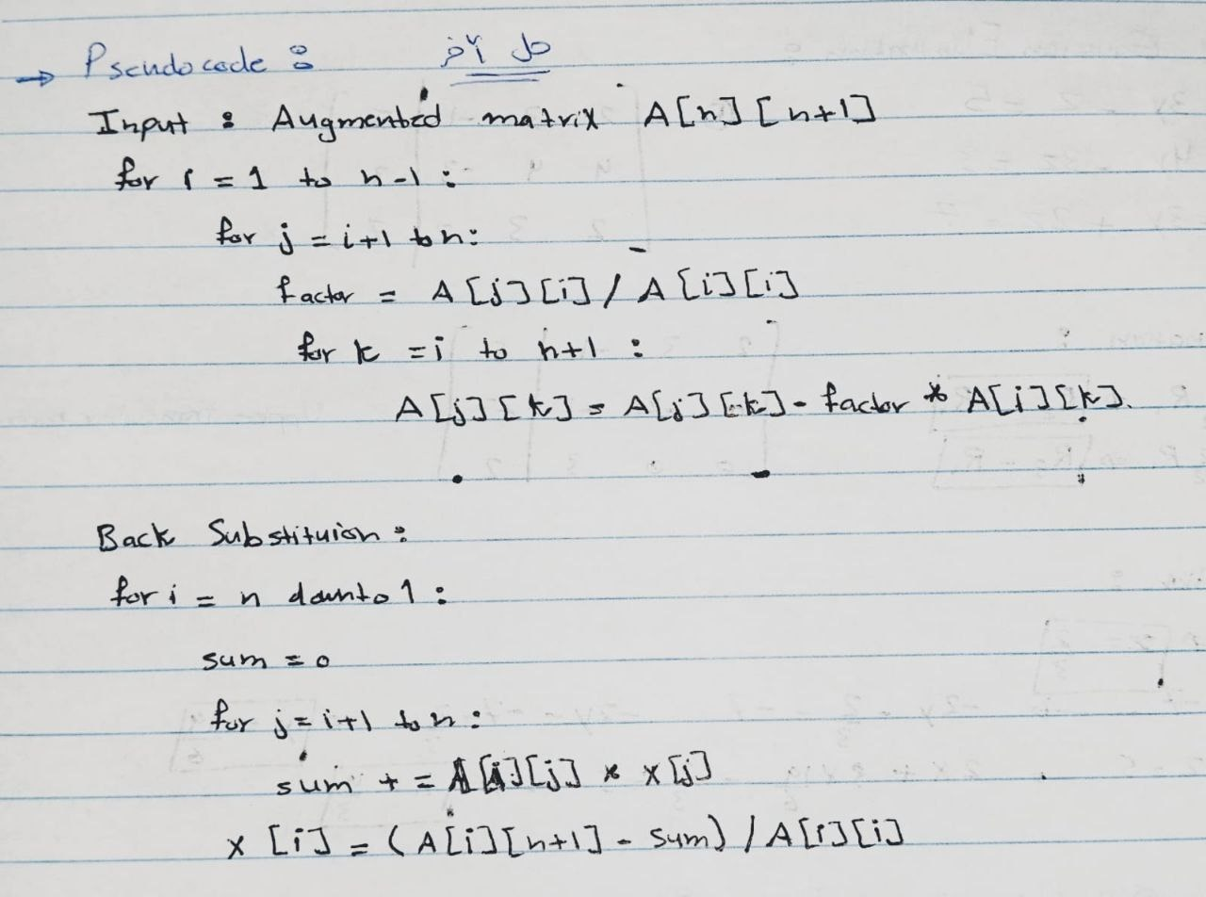

Q3/ The Implementation of Gaussian Elimination In Java Code:

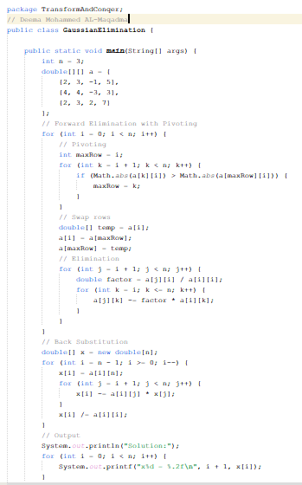

" واخر دعواهم ان الحمد لله رب العالمين "

